**Ghana’s GDP Grows at Fastest Pace in Five Years, Beats Estimates**

GDP rose 6.9% in second quarter; median estimate was 3.3%

All three of its largest sectors grew at faster rates

**Traders at Nima market in Accra.Photographer: Ernest Ankomah/Bloomberg**

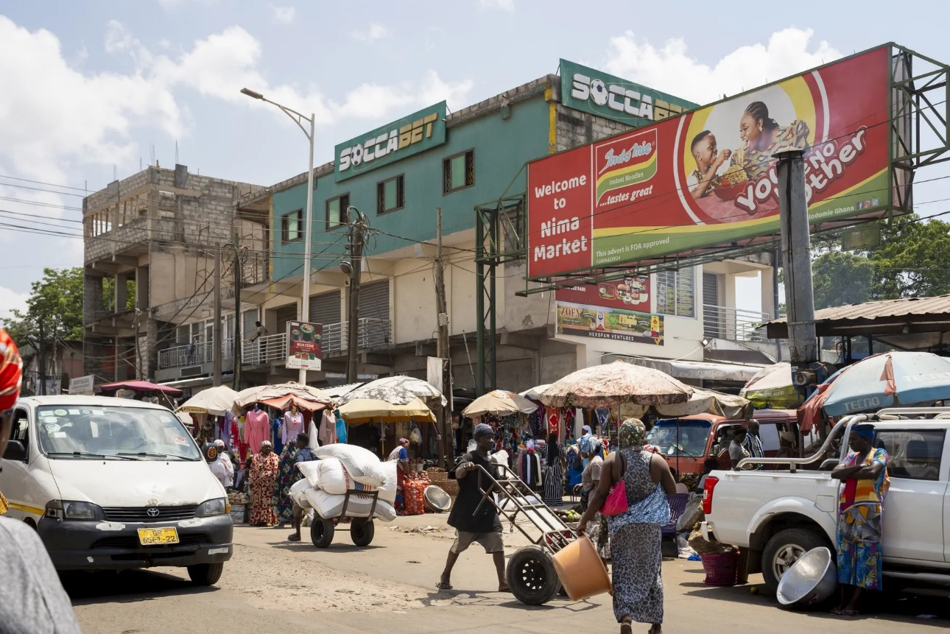

By Ekow Dontoh and Moses Mozart Dzawu

September 18, 2024 at 10:25 AM GMT

Updated on September 18, 2024 at 11:18 AM GMT

Ghana’s economy expanded at its fastest pace in five years in the second quarter, beating economists’ estimates by more than double, after better performances in its three largest sectors.

Gross domestic product grew 6.9% in the three months through June from a year earlier, compared with a revised 4.8% in the prior quarter Government Statistician Samuel Kobina Annim told reporters in the capital, Accra, on Wednesday. The median of three economists’ estimates in a Bloomberg survey for expansion was 3.3%.

The cedi traded relatively unchanged at 15.7 per dollar at 10:56 a.m. in the capital, Accra. Ghana bonds maturing in 2032 rose 0.2 cent to 52.59 cents on the dollar.

The better-than-expected outcome may boost Vice President Mahamudu Bawumia’s election campaign. Bawumia, who is the ruling New Patriotic Party’s presidential candidate for the Dec. 7 vote, is considered the underdog to opposition leader John Dramani Mahama for the top job because of public frustration over the NPP’s handling of the economy and the high cost of living.

The West African nation is exiting a prolonged debt restructuring and is in the second year of an International Monetary Fund program that’s included painful austerity measures.

Bawumia has said he would lift economic growth to an average of 6% a year by boosting agriculture and small businesses, and through new mining projects if elected president. He also pledged to use technology to make the government more efficient and to introduce a “friendly” tax regime to spur the private sector.

The industrial sector grew by an annual 9.3% in the period, after expanding 6.8% in the first quarter. Growth in the agriculture and services sectors accelerated to 5.4% and 5.8% respectively, compared with a revised 4.7% and 3.2% previously.

The better showing in agriculture, which employs an estimated 40% of the workforce, came even as the cocoa subsector contracted for a fourth straight quarter by 26.2%. Ghana is the world’s second largest producer of the ingredient used in chocolate and has seen production slump because of adverse weather, disease, a lack of inputs and smuggling of the beans.